**What is a Test Plan?**

* A Test Plan is a critical and exhaustive document that outlines the strategies, goals, timeline, estimations, deadlines, and which ultimately work together to ensure that all your software components are tested sufficiently before a release.
* It provides a framework that is designed by QA managers to provide clarity about the necessary tests that you need to verify to ensure the proper functioning of the software.

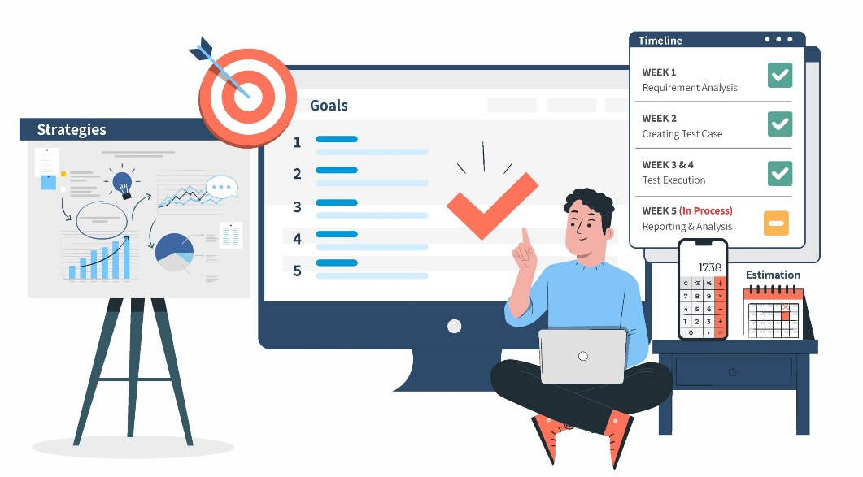

### ****Why is Test Plan creation important?****

* Reduction in defects
* Improved quality
* Resource utilization
* Faster time to market
* Mitigate risks

**six steps to create an efficient test plan:**

1. Define the release scope
2. Schedule timelines
3. Define test objectives
4. Determine test deliverables
5. Design the test strategy
6. Plan test environment and test data

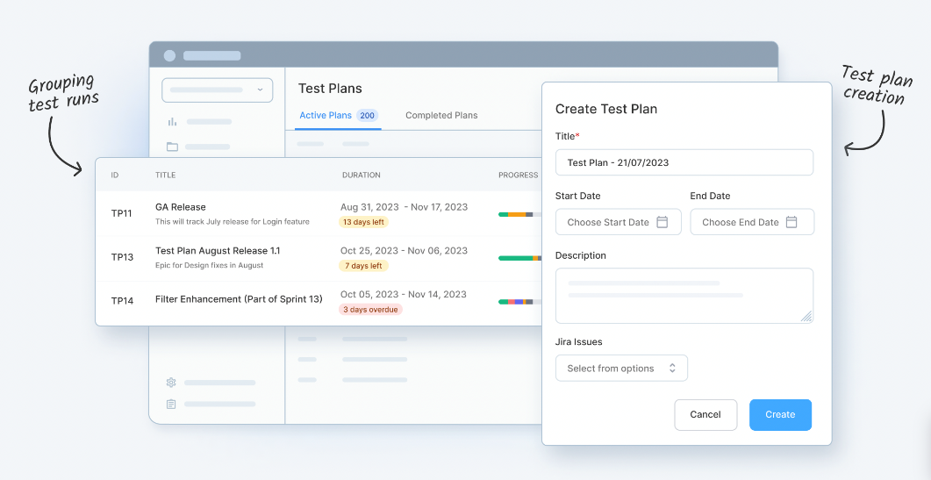

* + **Define the release scope:-**
* Before any test activity occurs, it’s important to define the scope of testing for your release.
* features or functions that need to be included in the release, considering any constraints and dependencies that can affect the release, and determining what type of release it is.

**Questions** to ask when defining the release scope include:

* Are there new features being released in this version?
* What are the risk areas?
* Are there any particularly sticky areas where you’ve seen regressions in the past?
* What type of release is it? Is this a maintenance release that includes bug fixes? Is this a minor feature release? Is this a major feature release?
* What does being “done” actually look like for your team?
  + **Schedule timelines**
* Specify release deadlines to help you decide your testing time and routine.
* **Define test objectives**
* A test objective is a reason or purpose for designing and executing a test.
* These objectives ultimately help guide and define the scope of testing activities.

**Examples** of general test objectives include:

* Identifying and reporting defects
* Testing new features
* A certain level of test coverage

Examples of objectives for specific types of testing include:

* + **Functional testing objectives**: Ensure the software works as it should.

Examples of goals for this objective include: Validating user workflows, data processing, and verifying input/output parameters.

* + **Performance testing objectives**: Ensure the software is efficient and can handle various loads.

Examples of goals for this objective include: Verifying software reaction time, throughput, and scalability.

* + **Security testing objectives**: Uncover program security flaws.

Examples of goals for this objective include: Verifying authentication and authorization features and identifying potential threats.

* + **Usability testing objectives**: Concentrate on ease of use and user experience.

Examples of goals for this objective include: Validating software accessibility, verifying user flow, and identifying user-related issues.

* **Determine test deliverables**

Test deliverables are the products of testing that help track testing progress. Deliverables should meet your project’s and client’s needs, be identified early enough to be included in the test plan, and be scheduled accordingly.

There are different test deliverables at every phase of the software development lifecycle. Here are important deliverables to focus on before, during, and after testing:

**Before testing**

**Test plan document**: The scope, objectives, and approach of the testing endeavor are all outlined in the test plan.

**Test suite**: Test cases illustrate how to run a test, including input data, expected output, and pass/fail criteria.

**Test design and environment specifications**: The test environment outlines the hardware and software configurations used for testing.

**During testing:-**

**Test log**: The test log records each test case’s results, including issues and resolutions.

**Defect report**: A defect report lists testing issues by severity, priority, and reproducibility.

**Test data**: According to the International Software Testing Qualifications Board (ISTQB), test data is data created or selected to satisfy the execution preconditions and input content required to execute one or more test cases.

**Test summary report:** The test summary report lists the number of tests run, passed, and failed, as well as open defects.

**After testing:-**

**Test completion report**: Covers the testing scope, product quality, and lessons discovered.

**User acceptance test (UAT) report:** Points to any issues found and fixed.

Release notes: List information about what the release includes. Examples include any new features for development, advancements, or fixes.

* **Design the test strategy**

Test strategy helps determine test cost, test effort, and which features will be in-scope (planned to be tested) versus out-of-scope (not planned to be tested).

* **Plan the test environment and test data**

Planning a test environment guarantees precise and robust testing. The test environment includes hardware, software, and network configurations for software testing.